AGENTCRAFT
Multi-Business Conversational Flow Specification
Retail · Service · Tech — Role-Based Chat Flows, Loops & Exit Logic

1. How to Read This Document
This document explains, in plain language and tables, exactly what the AgentCraft bot says and asks at every step, for every business type and every role — and how each part of the conversation loops back on itself.
Each business (Retail, Service, Tech) is built the same way:
- An entry menu — the first thing a user sees for that business.
- Four role-based tracks — CEO, Manager, Lead, and Employee — each with its own short question sequence.
- A repeating operational loop — the cycle of work that business runs on (e.g. Receive Order → Pack → Ship → Repeat).
Every table below reads top to bottom, in the exact order the bot asks. The "Options / Input" column shows exactly what the user can tap or type at that step.
Note: Every single action anywhere in AgentCraft — no matter the business or role — ends by asking the same universal question: “Perform another action?” This is covered once, in Section 3, and applies everywhere.

2. The Master Flow (All Businesses)
Before looking at any single business, it helps to see the shape of the whole conversation. Every business — Retail, Service, or Tech — fits inside this same six-step skeleton:
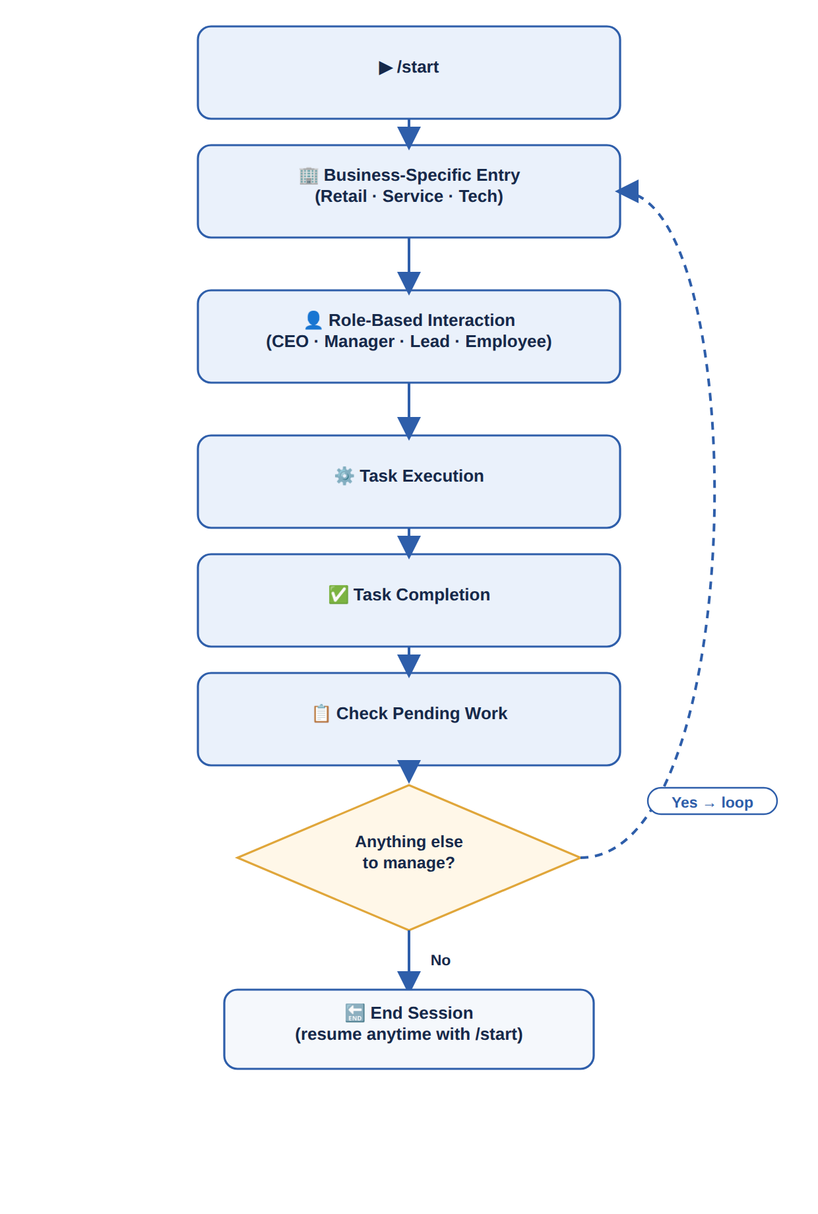
Figure 1 — Master Flow: the six-step skeleton shared by every business type.

2.1 Start, in Detail
The word “Start” hides a small decision the bot makes before showing anything. Here is exactly what happens, step by step:
Step | What Happens | Result
1 | User sends /start | Bot receives the command and looks up this chat_id
2 | Bot checks: is this chat_id already linked to a business and role? | Branches to Step 3a (returning user) or Step 3b (new user)
3a | Returning user | Bot skips setup and opens that business's entry menu directly (Section 4/5/6), already knowing the user's role
3b | New user | Bot asks which business type to set up: Retail, Service, or Tech
4 | Business-specific welcome message shown | e.g. “🛍 Welcome to AgentCraft — Retail Operations Hub”
5 | Top-level menu presented | User is now inside that business's entry menu and ready for role-based interaction
Why this matters: A returning Manager never has to re-answer setup questions — /start always drops them straight back into their own role's menu, not the beginning.

3. The Universal End-of-Action Loop
This is the single most repeated pattern in AgentCraft. It fires after every action, in every business, at every role level — so it only needs to be learned once.
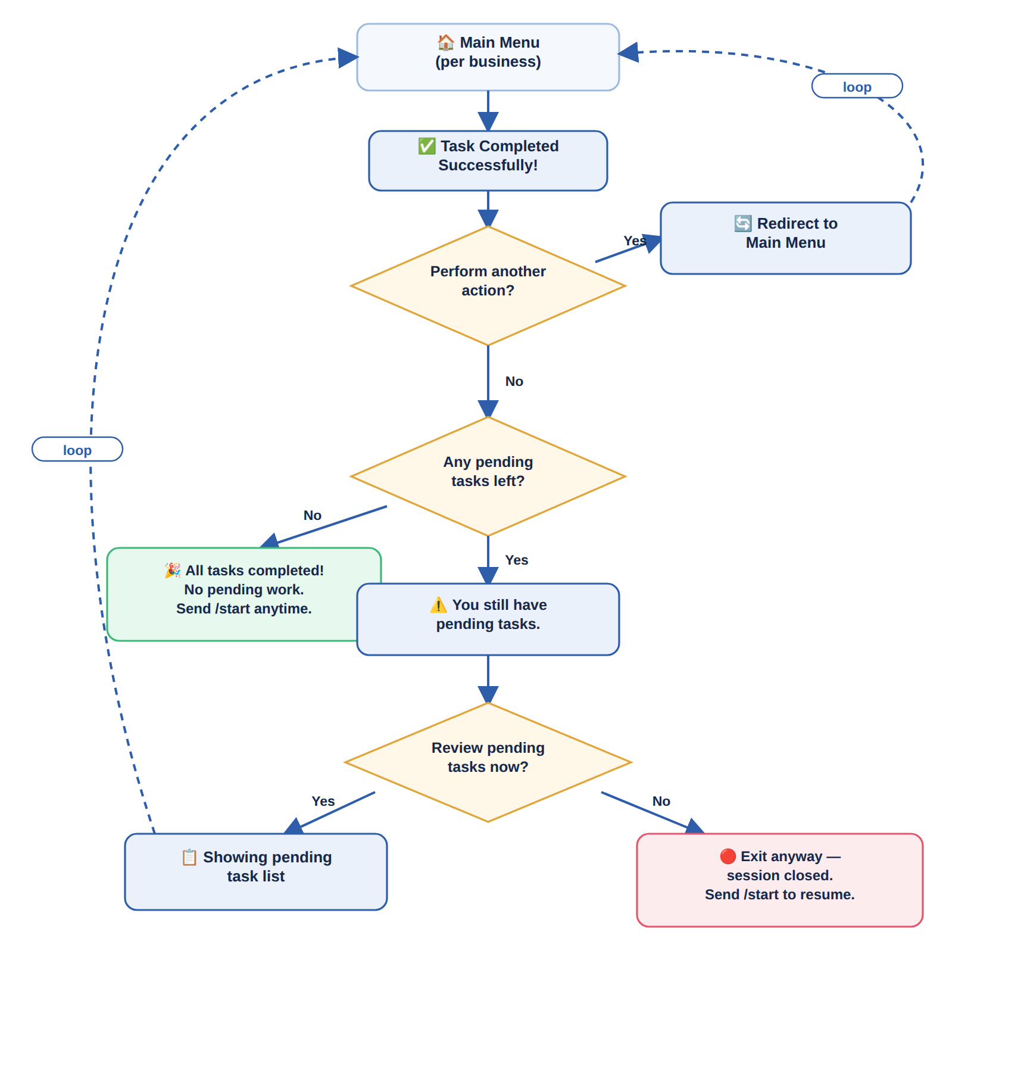
Figure 2 — What happens immediately after any task is completed.

3.1 Exit, in Detail
“Exit” is not a single ending — it is one of two distinct outcomes, depending on whether work is still outstanding:
Situation | Bot Message | What the User Can Do
Case 1 — Nothing pending | “🎉 All tasks are completed! No pending work remains. You can type /start anytime to continue.” | Session ends cleanly; sending /start later reopens the same role menu instantly
Case 2 — Work still pending | “⚠ You still have pending tasks. Would you like to review them?” | Review → bot shows the pending list and loops back into the menu. Exit Anyway → session closes, resumable with /start
Design rule: The bot never silently exits while work is outstanding — it always surfaces pending items first and lets the person choose, rather than assuming they meant to leave things unfinished.

3.2 The Master Loop Question
Regardless of business or role, the bot always closes the circle with the same question, worded consistently everywhere:
Repeated every time: “Is there anything else you'd like to manage?” — Yes routes back into the current business menu; No moves to the Section 3.1 exit check.

3.3 Universal Commands (Work Anywhere, Anytime)
A handful of commands sit outside the normal question-and-answer flow. They interrupt whatever is currently being asked and work identically no matter which business, role, or step the person is on:
Command | What It Does | Bot Response
/start | Resumes the session at the person's own role menu (or begins setup for a brand-new user) | Opens the correct business-specific entry menu — see Section 2.1
/menu | Jumps straight back to the current business's entry menu, abandoning whatever question was mid-flight | “Returning to the main menu.”
/help | Explains the options available at the current step, in plain language | “Here's what you can do right now: …” + the same options again
/switch | For a CEO or user linked to more than one business, changes which business the bot is currently managing | “Which portal would you like to switch to?” + list of linked businesses
/cancel | Abandons the current multi-step action (e.g. mid-way through assigning a task) without saving it | “Cancelled. No changes were made.”, then returns to the main menu

3.4 Handling Invalid or Unexpected Input
People don't always answer exactly as expected — they mistype, send the wrong thing, or go quiet mid-conversation. AgentCraft handles all three the same gentle way: restate, don't scold.
Situation | Bot Message | Outcome
Free text sent where buttons were expected | “I didn't quite catch that — please choose one of the options below:” | The same keyboard is shown again; nothing is lost
An option that doesn't exist is selected (e.g. a stale button from an old message) | “That option isn't available anymore. Here are your current choices:” | Bot re-sends an up-to-date keyboard for the current step
No response for an extended period | “Still there? Send /start anytime to pick up right where you left off.” | Session quietly pauses; no data is lost, no repeated nagging
Design rule: The bot never leaves a person stuck without a next step — every invalid input gets a plain-language nudge and the same options again, not an error code.

4. Retail Business — Inventory, Orders & Sales

4.1 Entry Menu
Every Retail conversation opens the same way, regardless of who is talking to the bot:
Bot Message | Options
🛍 Welcome to AgentCraft — Retail Operations Hub.  What would you like to manage today? | 📦 Inventory 🧾 Orders 💰 Sales 📊 Reports

4.2 Role-Based Tracks

4.2.1 CEO — Strategic + Monitoring
Focus: Sales + Stock + Business Health
Step | Bot Message | Options / Input
Q1 — Business Overview | Would you like to view today's business summary? | Yes / Skip
Q2 — Sales Insight | 💰 Today's Sales: ₹45,000 📦 Orders: 32. Would you like to: | View Detailed Report / Check Top Products / Continue
Q3 — Inventory Alert | ⚠ 5 products are low in stock. Do you want to restock them now? | Yes (→ Q4) / Remind Later
Q4 — Restock Action | Select products to restock: | Product A / Product B / Product C
Q5 — Expense Overview | 🧾 Monthly expenses: ₹18,500. Would you like a breakdown? | View Breakdown / Skip
Q6 — Staff Performance | 👥 Would you like to view staff performance rankings? | Yes / Skip

4.2.2 Manager — Operations Control
Focus: Orders + Task Assignment
Step | Bot Message | Options / Input
Q1 — Order Handling | 📦 You have 12 new orders. What would you like to do? | Assign Orders / View Details / Delay
Q2 — Assign Order | Select employee for Order #102: | Employee A / Employee B
Q3 — Priority Setting | Set priority for this order: | High / Medium / Low
Q4 — Tracking | Would you like to track ongoing orders? | Yes / No
Q5 — Customer Complaint | 😟 1 customer complaint received for Order #98. Handle now? | Yes / Later
Q6 — Confirm Assignment | ✅ Order #102 assigned to Employee A. Notify them now? | Yes / No

4.2.3 Lead — Distribution & Supervision
Step | Bot Message | Options / Input
Q1 — Task Distribution | You have 5 pending orders. Distribute them now? | Yes / Later
Q2 — Progress Check | Check team progress? | View Status / Skip
Q3 — Issue Handling | ⚠ Delay detected in Order #105. Do you want to escalate? | Yes / Handle Myself
Q4 — Reassign Task | Employee A is unavailable. Reassign Order #103? | Yes / Keep Assigned

4.2.4 Employee — Execution
Step | Bot Message | Options / Input
Q1 — Task Start | 📦 Order #102 assigned. What would you like to do? | Start Packing / Ask Question
Q2 — Progress Update | Update order status: | Packed / Shipped
Q3 — Completion | Mark order as completed? | Yes / Not Yet
Q4 — Report an Issue | Are you facing a problem with this order? | Report Issue / All Good

4.3 The Retail Loop
Once an order enters the system, it cycles through the same six stages every time:
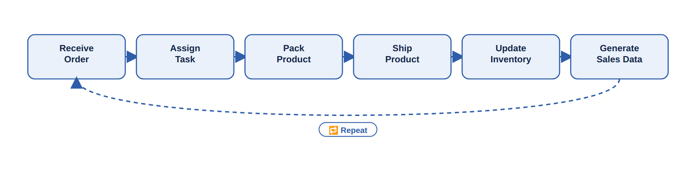
Figure 3 — Retail operational loop: every order follows this exact path.

5. Service Business — Projects & Clients

5.1 Entry Menu
Bot Message | Options
💼 Welcome to AgentCraft — Service Workspace.  What would you like to manage? | 📁 Projects 👥 Clients 📊 Progress

5.2 Role-Based Tracks

5.2.1 CEO
Step | Bot Message | Options / Input
Q1 — Project Overview | Would you like to review active projects? | Yes / Skip
Q2 — Performance | 📊 3 projects are delayed. What would you like to do? | Investigate / Notify Manager / Ignore
Q3 — Client Satisfaction | 📋 Latest client satisfaction score: 4.6 / 5. View feedback details? | Yes / Skip

5.2.2 Manager
Step | Bot Message | Options / Input
Q1 — Create Task | Create a new task? | Yes / View Existing
Q2 — Task Input | Enter task objective: | Free text (e.g. “Design homepage”)
Q3 — Assign Task | Assign task to: | Designer A / Designer B
Q4 — Deadline | Set deadline: | Today / Tomorrow / Custom
Q5 — Reassign Task | Designer A is overloaded. Reassign task to Designer B? | Yes / No

5.2.3 Lead
Step | Bot Message | Options / Input
Q1 — Monitor Work | Check team progress? | Yes / No
Q2 — Quality Check | Is the submitted work acceptable? | Yes / Needs Revision
Q3 — Deadline Extension | Employee requested a deadline extension. Approve? | Approve / Deny

5.2.4 Employee
Step | Bot Message | Options / Input
Q1 — Start Work | Task assigned: Design homepage. Action? | Start Work / Ask Question
Q2 — Submission | Submit your work: | File / Link
Q3 — Confirmation | Submit final version? | Yes / Edit
Q4 — Feedback Received | 📩 Manager left feedback on your submission. View now? | Yes / Later

5.3 The Service Loop
The Service loop includes one branch the others don't: work that fails quality check goes back for revision before it can be marked complete.
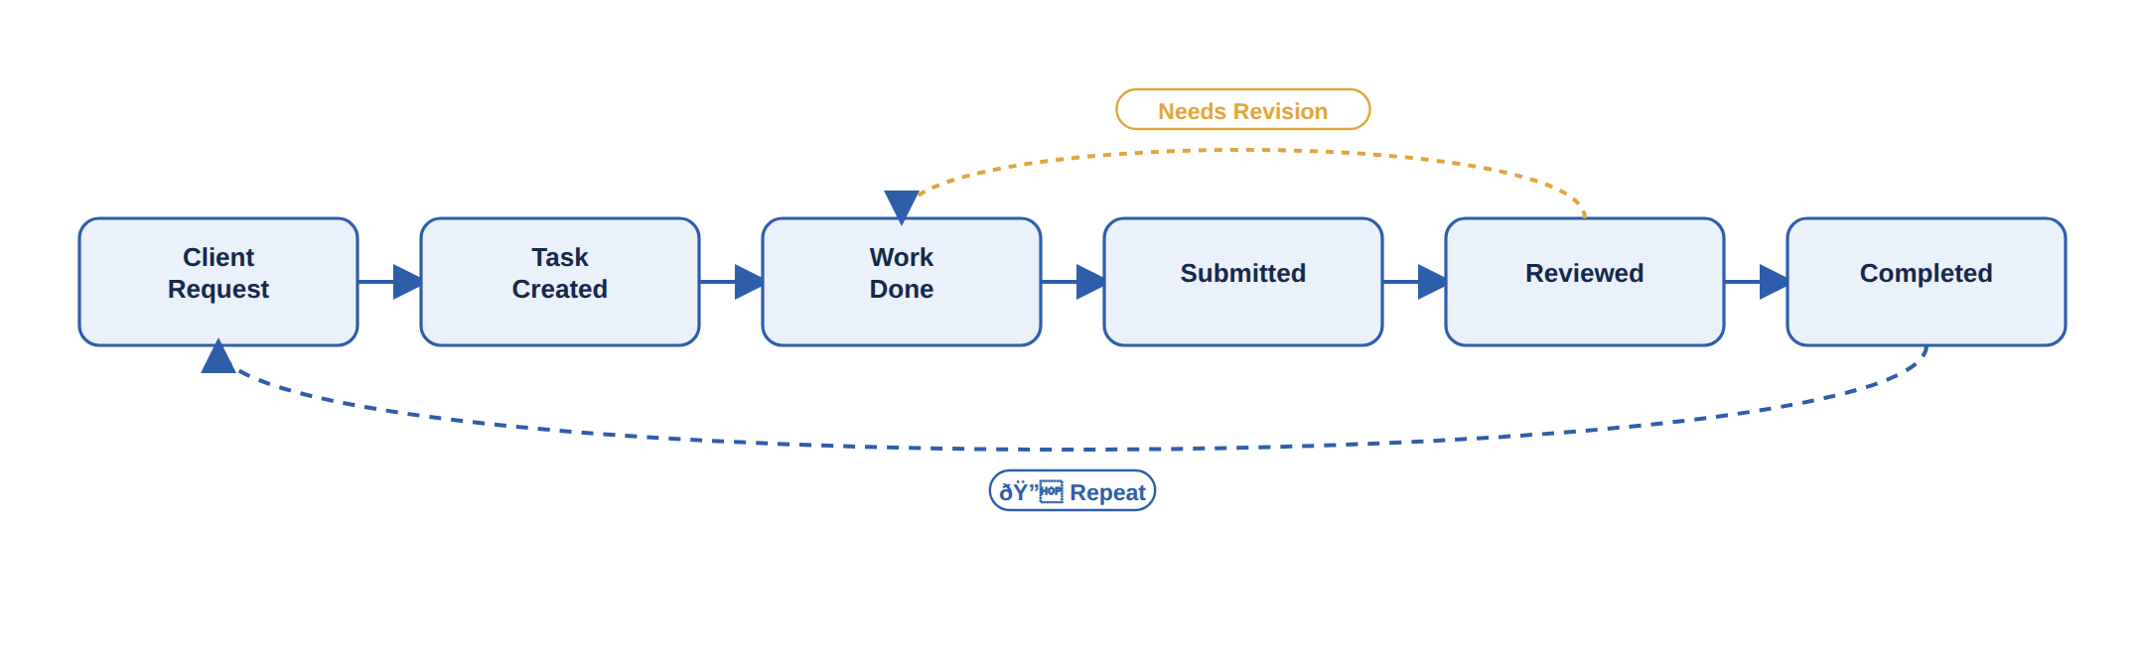
Figure 4 — Service operational loop, with the revision branch shown in amber.

6. Software / Tech Business — Dev Console

6.1 Entry Menu
Bot Message | Options
💻 Welcome to AgentCraft — Dev Console.  What would you like to manage? | 🐞 Bugs 🚀 Features 📦 Releases

6.2 Role-Based Tracks

6.2.1 CEO
Step | Bot Message | Options / Input
Q1 | Check system performance? | View Metrics / Skip
Q2 — Release Readiness | 🚀 Is the next release ready for deployment? | Yes / Not Yet
Q3 — Security Check | 🔐 Run a security scan before release? | Yes / Skip

6.2.2 Manager
Step | Bot Message | Options / Input
Q1 | Assign new task: | Bug Fix / Feature Development
Q2 — Sprint Planning | 🗓 Plan next sprint now? | Yes / Later
Q3 — Set Priority | Set priority for this task: | High / Medium / Low

6.2.3 Lead
Step | Bot Message | Options / Input
Q1 | Track developer progress? | Yes
Q2 — Code Review | 👀 New pull request ready for review. Review now? | Yes / Later
Q3 — Blocker Escalation | ⚠ Developer reported a blocker. Escalate to Manager? | Yes / Handle Myself

6.2.4 Employee
Step | Bot Message | Options / Input
Q1 | Task: Fix login bug. Update status: | Working / Completed
Q2 — Submit Pull Request | Ready to submit your PR for review? | Yes / Not Yet
Q3 — Deployment Confirmation | Confirm your fix is deployed to staging? | Yes / No

6.3 The Tech Loop
The simplest of the three loops — a straight development cycle:
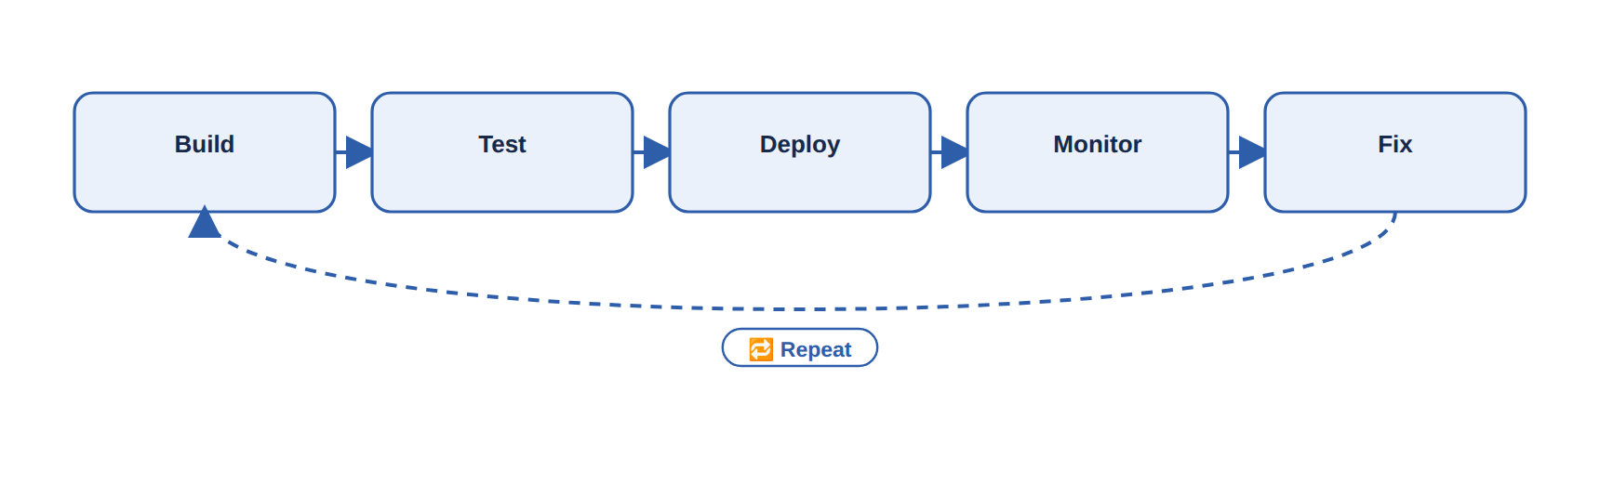
Figure 5 — Tech operational loop: Build, Test, Deploy, Monitor, Fix, Repeat.

7. Putting It All Together
Every business in AgentCraft is the same idea wearing different labels:
- A business-specific entry menu (Section 4.1 / 5.1 / 6.1)
- Four role tracks that ask short, specific questions (never more than one at a time)
- An operational loop that keeps the core work cycling (Figures 3, 4, 5)
- One universal end-of-action check that decides whether to loop or exit (Figure 2)
If you can read the Master Flow (Figure 1) and the Universal End-of-Action Loop (Figure 2), you already understand the skeleton of all three businesses — the rest is just which words fill in each box.

